MCKV INSTITUTE OF ENGINEERING

Computer Science and Engineering – Data Science

***Name - Abhinaba Sarkar***

***Roll No. - BTECH/CSE-DS/2020/47***

**Assignment Number: *5***

Problem statement:

An automorphic number is the number which contained in last digit(s) of its square. Example 25 is an automorphic number as its square is 625 and 25 is present as the last two digits. Write a python script to print all two digits automorphic numbers.

Assignment 5.a)

Source code:

print("Automorphic Numbers are: ",end=" ")

for i in range(10,100):

sqr=i**2

remainder=sqr%100

if i==remainder:

print(i,end=" ")

output:

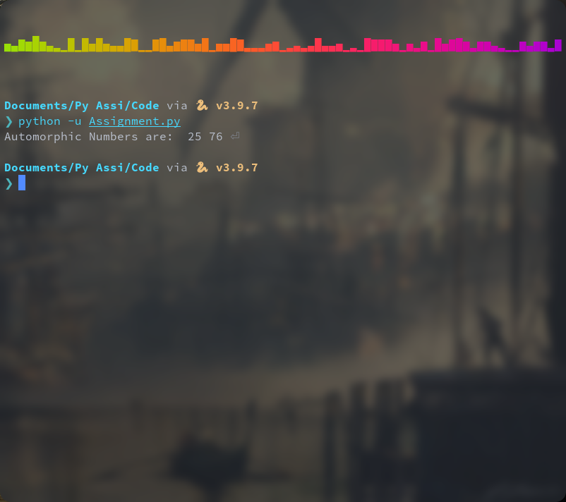

Problem statement:

A number is said to be a special number, if the sum of the factorial of the digits of a number is same as the original number. Example-145 is a special number, because 1! + 4! + 5! =145. Write a python script to print all special numbers within range 100 to 999.

Assignment 5.b)

Source code:

import math

print("Special Numbers within range 100 to 9999: ")

for i in range(100,10000):

some=0

j=i

while j>0:

rem=j%10

f=math.factorial(rem)

some=some+f

j//=10

if i==some:

print(i,end=" ")

output:

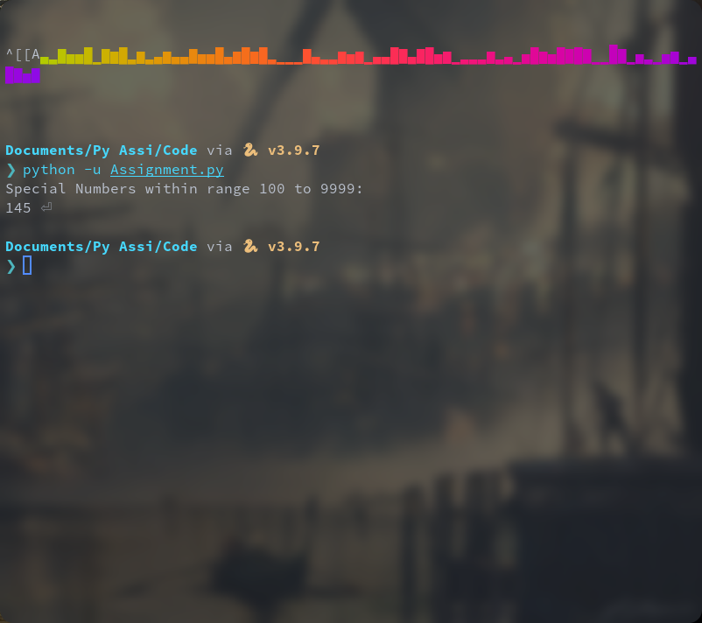

Problem statement:

Write three separate python programs to generate the following patterns.  
  
  
  
  
  
Assignment 5c1:

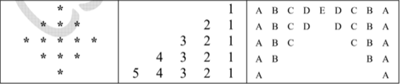

source code:

n = int(input("Enter the number of lines: "))

half = n // 2 + 1

for i in range(half+1):

print((" ")*(half-i)+("*")*(2*i-1))

for j in range(half-1, 0, -1):

print((" ")*(half-j)+("*")*(2*j-1))

output:

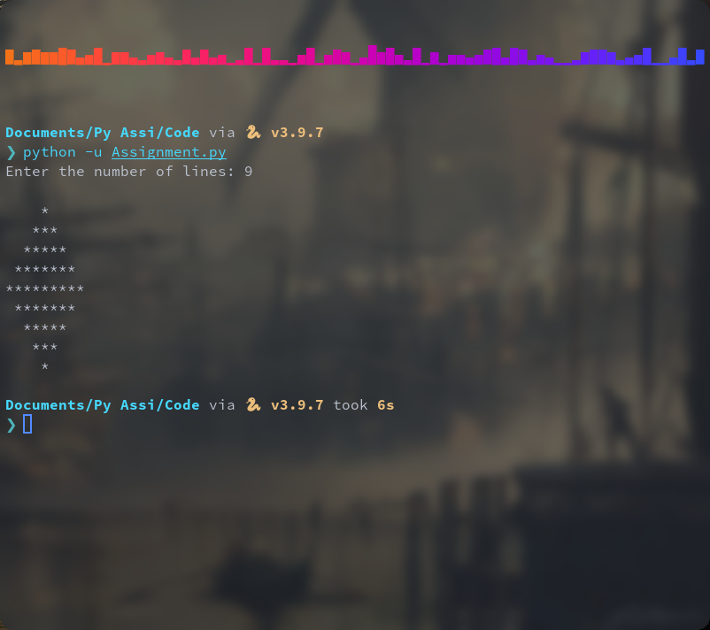

Assignment 5c2:

Source code:

n = int(input("Enter the number of lines: "))

for i in range(n):

for j in range(n-i-1):

print(" ",end=" ")

for j in range(i, -1, -1):

print(j+1 , end=" ")

print()

output:

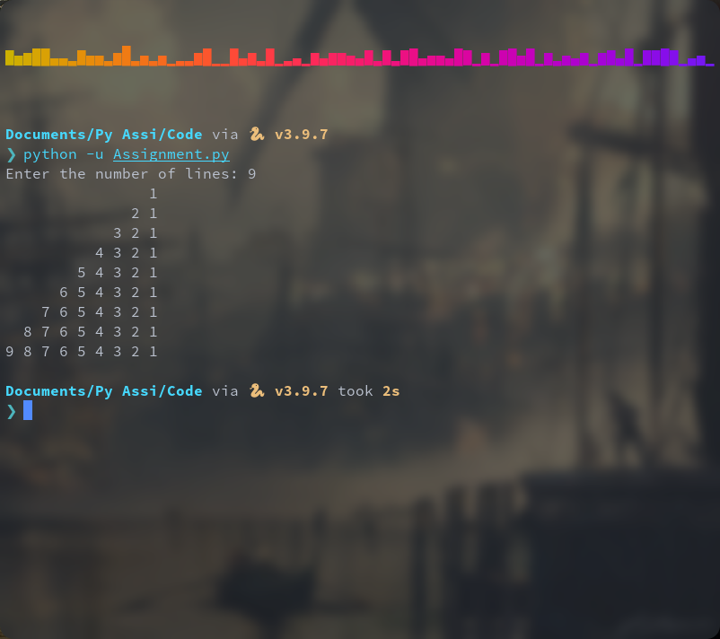

Assignment 5c3:

Source code:

n=int(input('Enter the no.of lines: '))

for i in range(n,0,-1):

for j in range(i):

print(chr(65+j),end='')

print(' '*(n-i)*2+'\b',end='')

for j in range(i-1,-1,-1):

print(chr(65+j),end='')

print('')

output:

